Conference on Asexuality
Hello,
We are now going to show you how asexuals are visible in France.
- Television documentaries
Some of us take part in television programs on French national channels. These programs are re-broadcasted several times a year.

- Newspaper articles
We accept interview requests for newspapers in which we give our testimonies, talk about asexuality and share information from asexual networks.
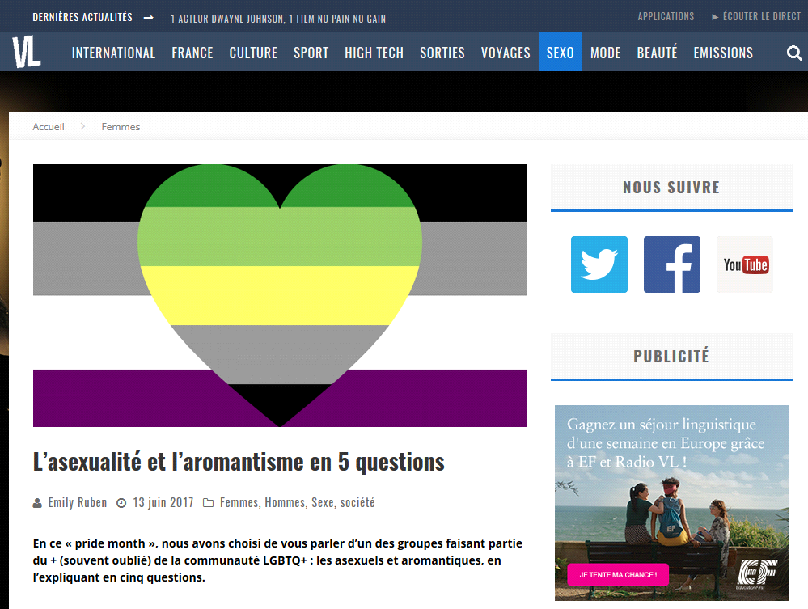
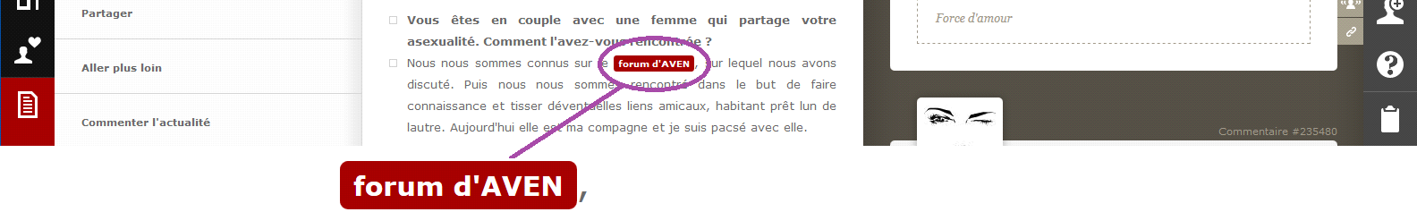
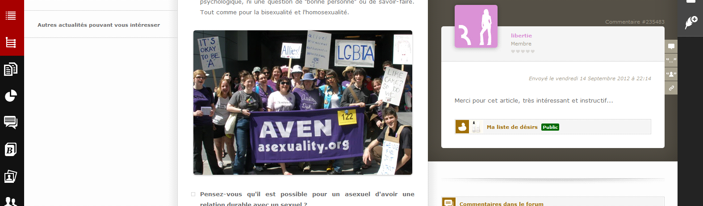
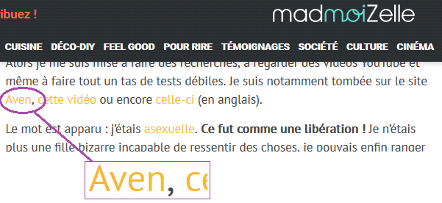

- Radio broadcasting
Some journalists contact us to make radio shows in which we can inform the public about the existence of asexuality and about how it’s a really normal sexual orientation.
- AVA
In France, an association separated from AVEN was created to better manage the visibility of asexuals: AVA (Association for Asexual Visibility). The association, like certain members of AVEN, responds to diverse requests from journalists. However, the association goes further by organizing interventions in French LGBT + (plus) centers such as le MAG Jeunes LGBT to provide information to speakers so that they can inform young people during their interventions, for example, in schools. This LGBT + (plus) centers and CGLBT Rennes now have one of their groups for asexuals and aromatics.

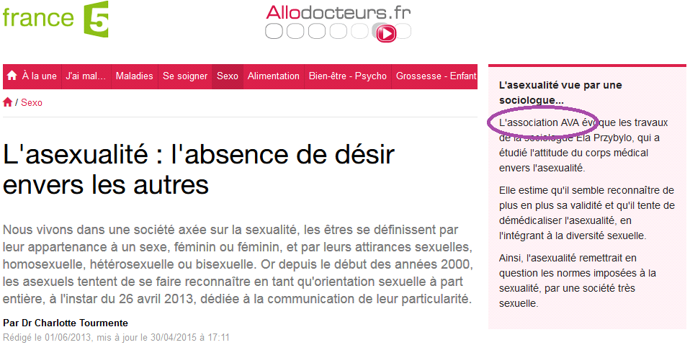
AVA members organize every year the presence of asexuals in the gay pride of Lyon and Paris.
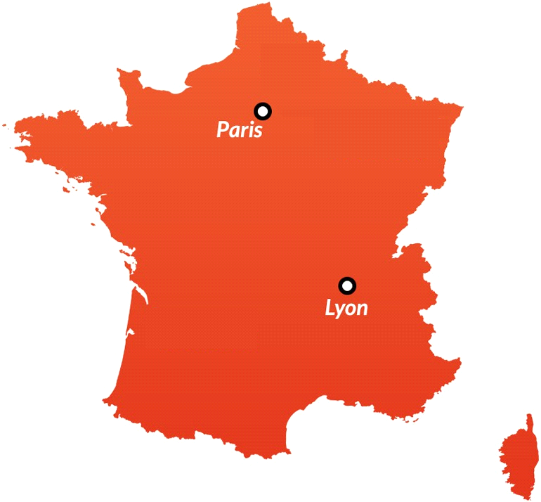
- French asexuality day
The association AVA created in 2013 (twenty thirteen) a French asexuality day on 26 (twenty six) April. Every year this day is celebrated by many French asexuals and allows to have a high visibility with their kinfolk.
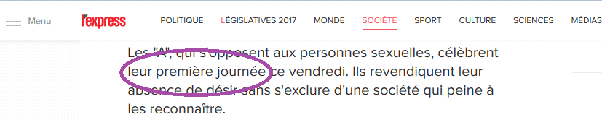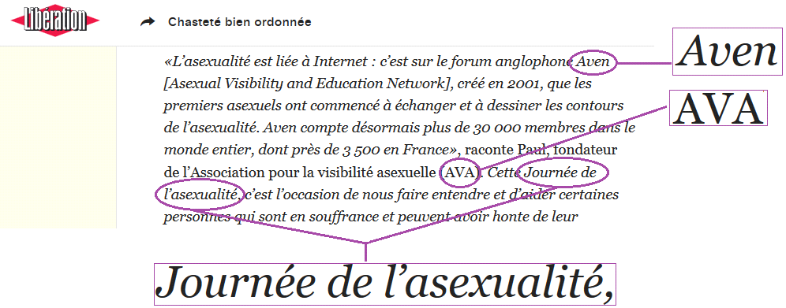
- The forum and its evolution
The website and forum of AVEN France is the biggest information and discussion network in France, it exists since 2005 (two thousand and five), it was then only a forum. For the last 4 years in which I am the administrator, I have made several improvements to the site and the forum for better exchanges between the members :
This is the website, only a forum, in 2005 (two thousand andfive) :
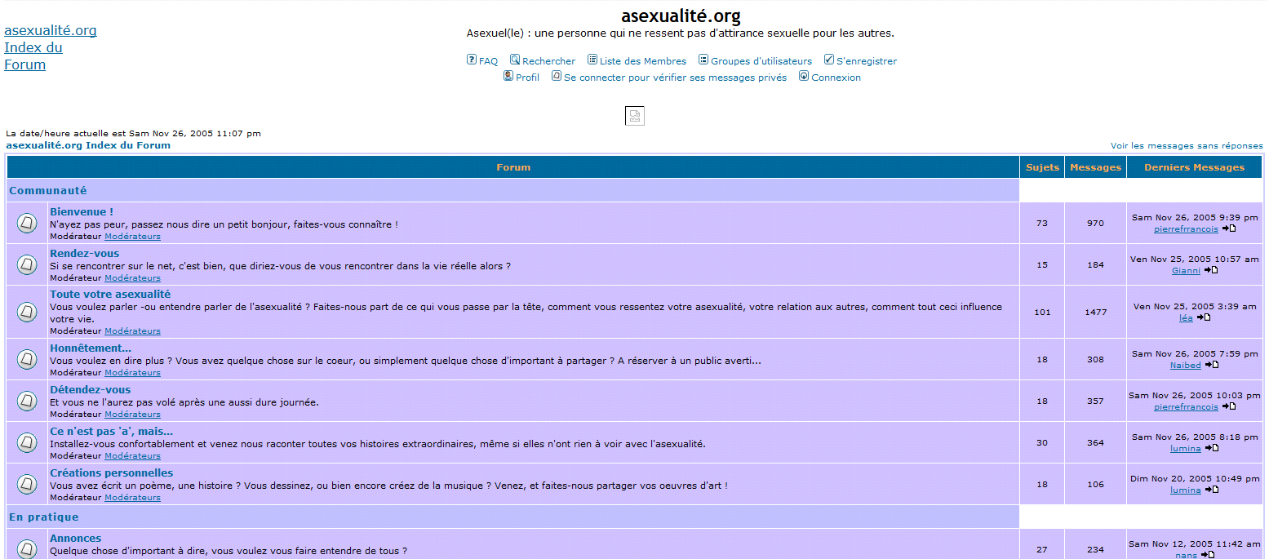
This is the website in 2013 (twenty thriteen) :
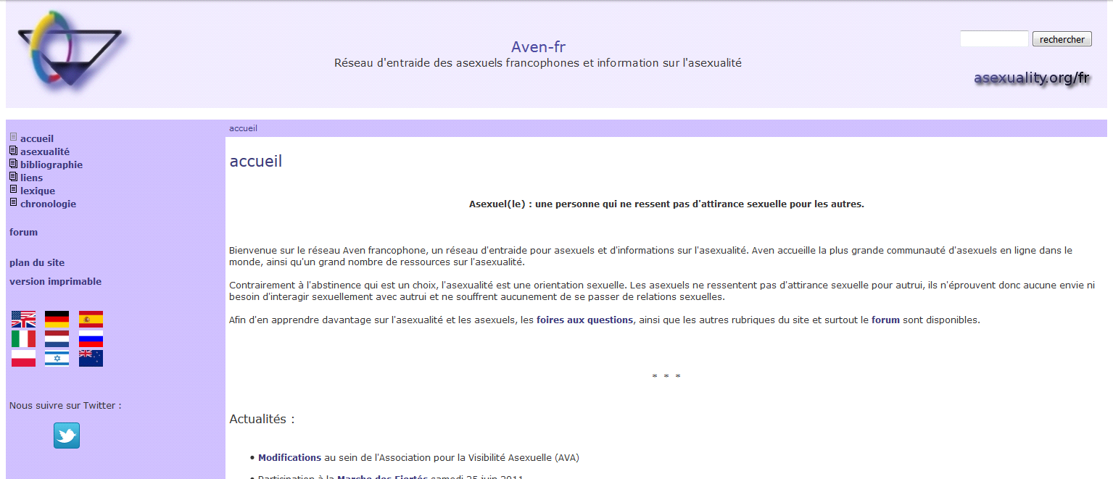
At the end of 2015 (twenty fifteen), we modified the logo of the website with the help of one of our members, then I improved the interface of the site. This is the website today :
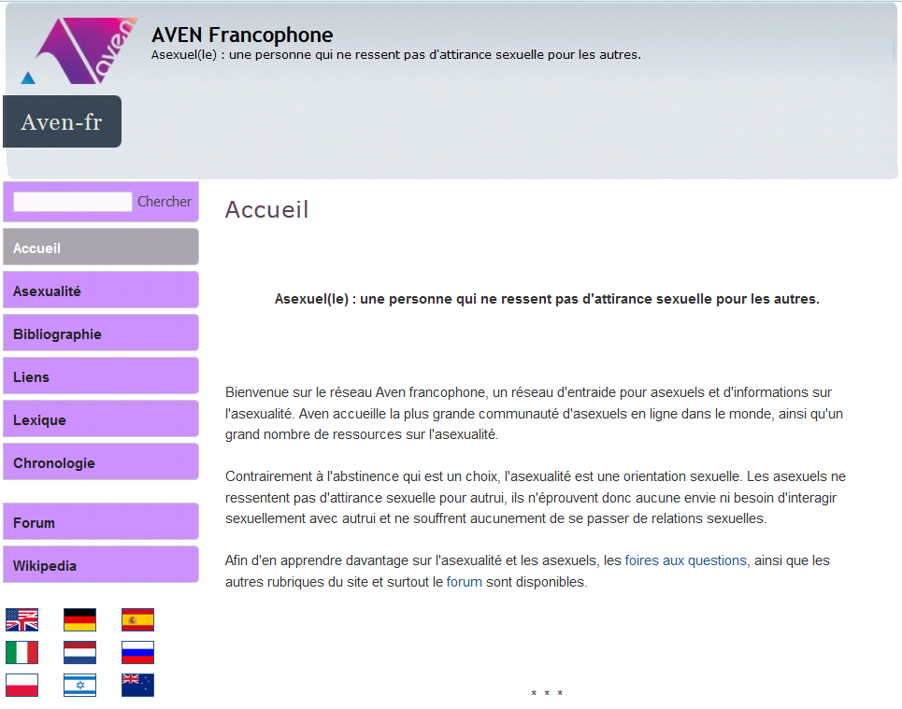
This is the forum in 2013 (twenty thirteen) :
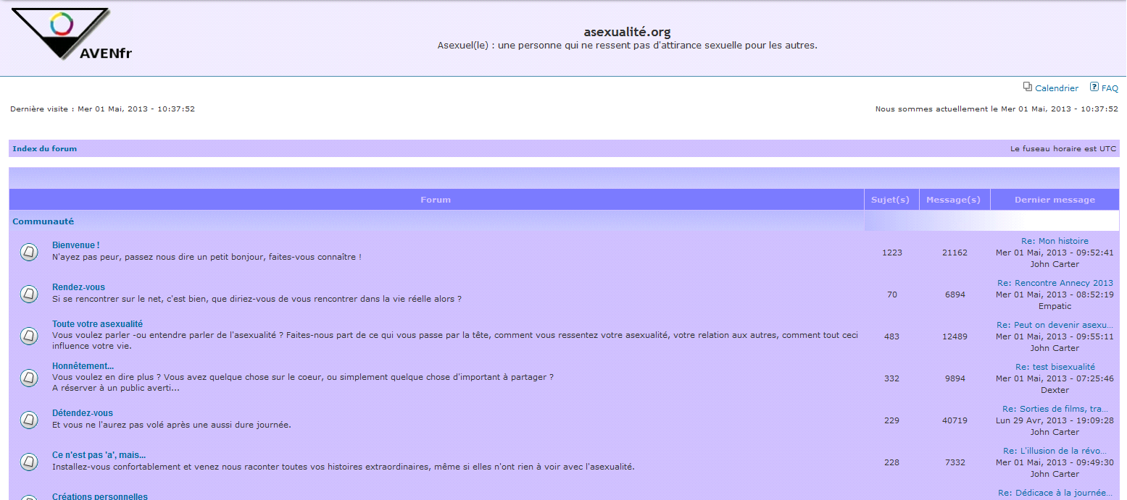
I proceeded to change the style of the forum following some updates. This is the forum today :
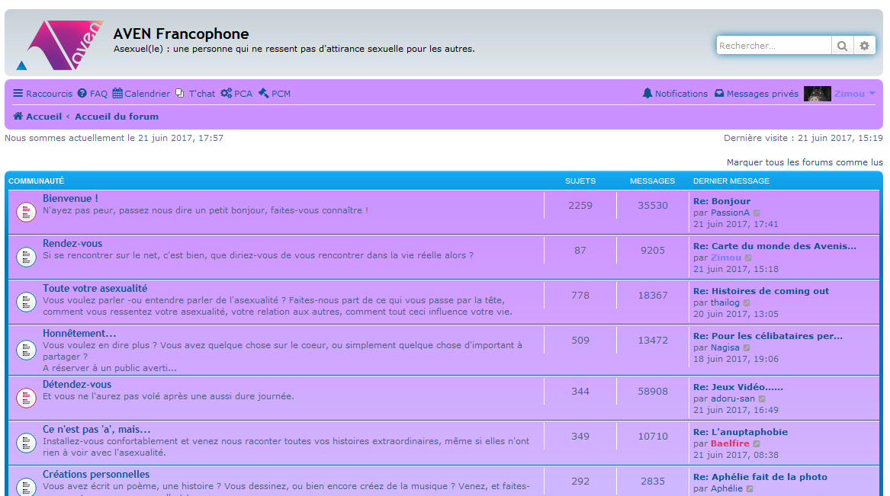
I added different functionalities to the forum so that members can interact better with each other. A chat was added first. Then I added a calendar module allowing members to organize events : gay prides, meetings between members, evening discussions, etc...
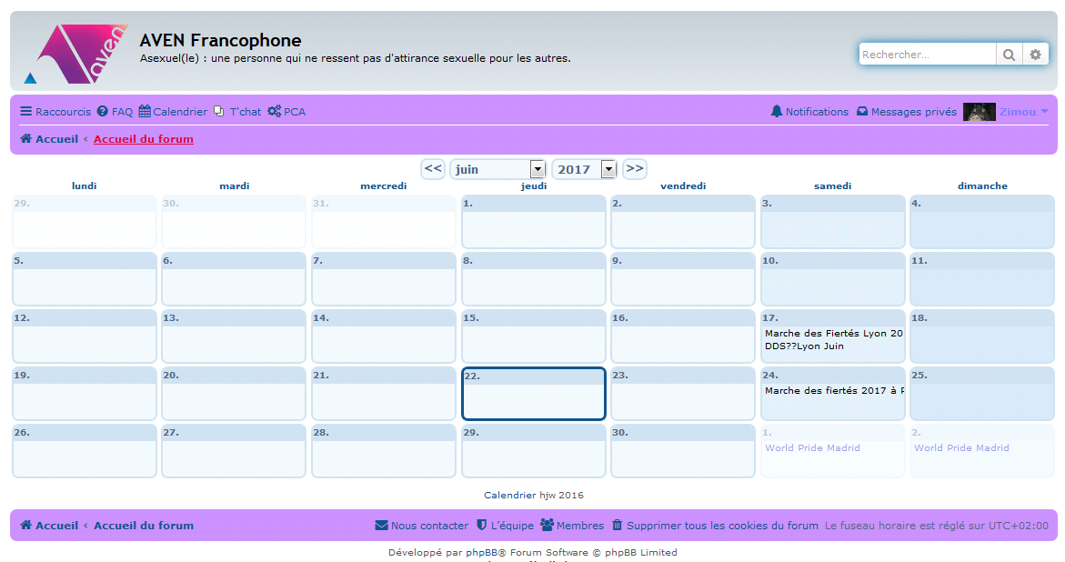
I finally added a "chat bar" which allows members to be able to chat at any time on the forum without having to connect to the chat page. Thanks to this, each evening several members meet together to discuss between themselves.
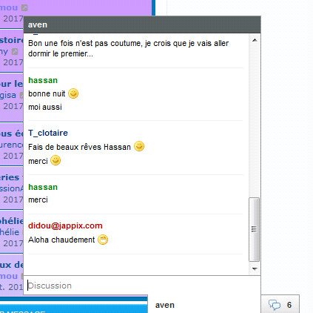
With this, several small features have been added with the updates of the forum : integration of media sharing (video, facebook, tumblr, ...), addition of notifications, small additional objects displayed on the forum following the season of the year, Etc…
In 2015, I added a wikipedia platform on our server. I imported all English wikipedia data and with the help of the members, we translated about 80% (eighty percent) of the articles in French. Thanks to that, we now have a great base of French-speaking knowledge of asexuality.
